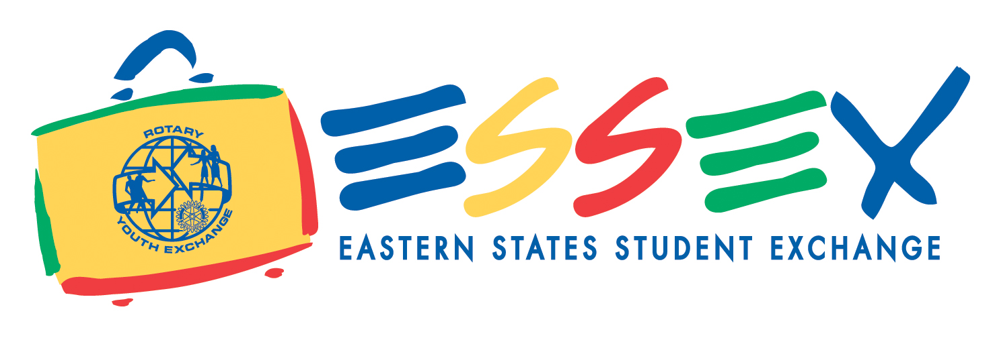

September 2019

Dear Rotary Youth Exchange Applicant:

It is a wonderful adventure you are about to embark on with Rotary Youth Exchange (RYE)! Your Youth Exchange Officer (YEO) will be happy to assist you with any questions you may encounter while filling out this application. Please make sure you download and use the application for your Sponsoring Club within Rotary District 7930 and not the one for another town or one downloaded from other Rotary websites, as the application form on https://rye7930.org has already been pre-filled in with the information for our District and your Sponsoring Club.

Read through the directions at least twice before starting your application. After you have finished the form, read through the directions again to make sure you have completed it correctly.

If you have trouble saving the form after you have inserted your information, try either using a different browser (e.g. Google Chrome), and/or save it to your desktop.

After you have completed this form, go over it completely with your YEO to make sure that it has been prepared correctly and has all the signatures required from your parents.

Mail or hand-deliver one complete form to your local Rotary Club YEO. Please do not print forms double sided as they need to be scanned.

Your YEO will verify all the information on the form, sign the application, and also get your Sponsoring Club’s President’s signature. Your YEO will then scan the form and provide me with an electronic copy via email, before sending the originals to me.

Application - PLEASE FOLLOW THESE DIRECTIONS:

Section A:
When you first type in your name, use this format as it will be inserted on all the pages thereafter: Susan Jane JONES. The last name should be in ALL CAPS.

Section B:
Your letter needs to be grammatically correct and interesting. This is what introduces you to your host country, host district, host club, and host family. This is probably the most important piece of your application. Make sure that your letter is at least two full pages. The quality of your letter greatly influences your placement! We will help you with that process, and you may be asked to make changes by your YEO or RYE team member.

When putting your photographs on page one and four, if you do not insert them digitally, paste one set on the form and then make one color copy for your application.

Sections C and D:
TYPE your physician/dentist's name, address, phone number and fax number on the page before you send it to him/her for signature. Forms with the medical provider's name hand written will be given back to you to do again. Also note that you need to get a TB test from your doctor and these take a few days.

All signatures, including medical providers and personal references, must be in BLUE INK.

Section H:
Please provide your teacher with a stamped envelope addressed to your YEO so that they can send it directly to your YEO. When you give the reference form to the teacher please tell them that they need to "explain their answers to questions 2 and 3, and to provide any additional comments on the applicant's suitability as an exchange student and cultural ambassador,” as set forth on the form. It might help if you highlight that paragraph before giving it to the teacher. The teacher must also sign the form in BLUE INK. Fill in your information at the beginning before giving the teacher the recommendation form. Forms with your name hand written will not be accepted.

You also need to include a sealed copy of your transcript with your application. This means with the school seal affixed on it, not in a sealed envelope (although your school will probably give it to you in a sealed envelope.)

Additional Documents:

1. A signed copy of the Guidelines, Conditions and Rules for Outbound Students

2. Although the checklist at the end says either passport or birth certificate, we only need a copy of your passport. The passport must be valid until February 2022. Be advised that the application cannot be processed without a valid passport. If your passport expires prior to February 2022, please apply for a renewal right now!

3. One copy of the Country Selections sheet. This will be your initial thoughts on where you would like to go on exchange, however, the final country selections will be determined at the interviews. Take note of any age or language restrictions when making your choices. Be advised that our district will not send you on exchange Australia, since we believe that learning a foreign language is an integral part of a successful cultural exchange program.

These documents must be mailed to me by your YEO no later than November 8, 2019. Make sure that you have checked everything off on page 13 of the application and that you are mailing a complete set to your YEO by November 1, 2018. The only item that is mailed to your YEO or to me separately is the teacher recommendation.

Our District Interviews will be held on Saturday, November 16, 2019, from 12:00 PM to 4:00 PM at the offices of Altova, Inc., 900 Cummings Center, Suite 314-T, Beverly, MA 01915. I will send directions when I forward your interview time slot. You are welcome to come before your scheduled interview and speak with our Inbound students about the exchange. The interview itself will last for about an hour and both the student and parents are required to attend.

After the interviews there will be a short window when you can supply documents that may have been missing from your application. Any such documents must be to me no later than November 22, 2019. If I do not have a completed application from you at that time I will return your application and your application fee, and your application will not be sent on to ESSEX for consideration. Keep in mind that applications received after the deadline date may reduce your available Country options.

Attached to this letter you will find a copy of the Fee schedule. We will go over these fees at our orientations, but if you have any questions please ask your YEO or contact me. There are some small scholarship funds available from ESSEX which we can help you apply for if needed.

If you have not looked at our District 7930 Youth Exchange website or the ESSEX website I suggest you make yourself familiar with all the information there. This will be useful as you go forward on your exchange as it has links to CISI/Bolduc Insurance and the travel agency you will be using, Tzell Youth Exchange. It also gives you other information you will find helpful:

- https://rye7930.org/
- http://www.exchangestudent.org/

We all look forward to working with you. Remember that this is an all volunteer organization so please be patient if we are not as prompt as you would like. We all do this because we believe in the program and we enjoy working with all of the students.

Sincerely,

Robert Ford
Rotary District 7930
Outbound Coordinator 2019-20
807 Turnpike St, Ste 201
North Andover, MA 01845
Telephone: 978-387-6005
rpf@fordlaw.net

Rotary Youth Exchange
District 7930 Fees
For 2020-2021 Outbounds

2020 - 2021 Rotary Youth Exchange Fees: $1,000*
Three installments as shown below. Checks payable to “Rotary Youth Exchange District 7930.”
If mailing, send to Robert Ford, 807 Turnpike St, Ste 201, N. Andover, MA 01845
Payable as follows:

Due 11/16/2019 $300
Due at District Interviews. Non-refundable after application is submitted to ESSEX (12/1/19).

Due 3/22/2020 $400**

Due 4/24/2020 $300**

Other Expenses:

Mandatory insurance-CISI/Bolduc (on-line enrollment) $567-839

Mandatory travel agent - Tzell Youth Exchange (registration fee) $125 (by 4/1/20)

Navy Blazer. All youth exchange students travel with a navy blazer. Style your choice. Try the thrift shop or a uniform shop. (Wool or linen, depending on the country and climate you’re off to….)

Pins: Buy them or make them. (Need 150 - 200)

Visa: Varies by country. (est. $50 - 300)

Airfare: Varies by country. (est. $1500 - 2500)

Host District Fees: Varies by country (est. $1000-1500)
(May include refundable damage deposit and district travel expenses)

Travel and spending varies by country and by individual. (Travel est. $1,500)

POSSIBLE ADDITIONAL EXPENSES:
Language Camp (mandated by some countries) est. cost $300-1000
Additional insurance (required by some countries) est. cost $600-1000

TOTAL ESTIMATED COST OF PROGRAM: Est. $7,500 – 9,500

*Fees of $1000 include orientation sessions, business cards, badges.
**Non-refundable.

